TIC I TO

Hans Le Roy (1)

[Hans.leroy@odisee.be](mailto:Hans.leroy@odisee.be)

[www.hlrnet.com/sites/bet](http://www.hlrnet.com/sites/bet)

1, colaborar: control de cambio

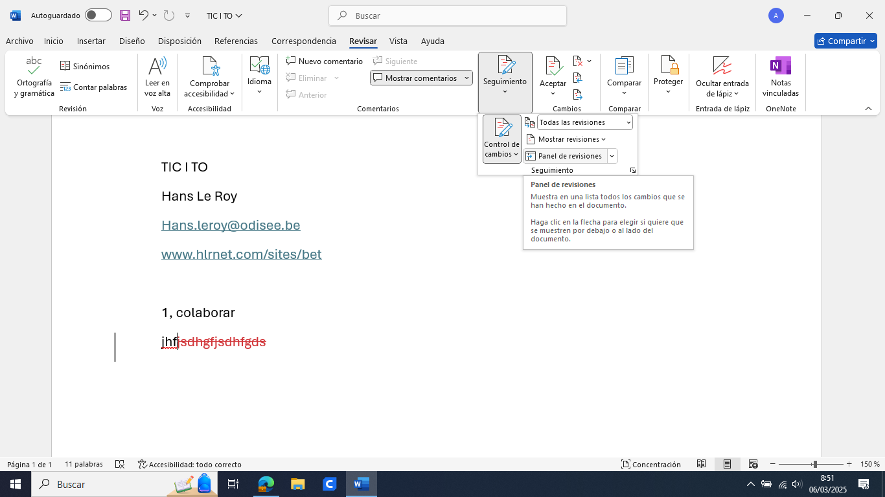

2. bibliografía (2)

Linguee

Reverso

DOI

Pinchar con la rueda del ratón

Mendeley.com

Bibliografía

1. Le Roy H. CSEU 2025: TIC I TO [Internet]. 2025 [cited 2025 Mar 6]. Available from: https://hlrnet.com/sites/bet/?p=1480

2. Connors C, McNeill S, Hrdlicka HC. Occupational and Physical Therapy Strategies for the Rehabilitation of COVID-19-Related Guillain-Barré Syndrome in the Long-term Acute Care Hospital Setting: Case Report. JMIR Rehabil Assist Technol. 2022 Feb 10;9(1):e30794.

* Cuenta
* Dentro del navegador: instalar Mendeley web importer
* Word: insertar, complemeto, Mendeley

3. lectura

- Tagcrowd

- resoomer

- jungle AI

- Revisely

- Word

4 hlrnet.com

IA

EBP

[Bélgica España vía TO – Bruselas BE – Burgos Madrid Zaragoza ES // enfermería y terapia ocupacional](https://hlrnet.com/sites/bet/)